**Dobell, William (1899 – 1970)**

William Dobell was an icon of Australian art during his lifetime, renowned for portraiture but also for the controversy surrounding his being awarded the Archibald Prize (1943). From 1929 he developed his signature expressionist style of exaggerated features and distortion with a sense of satire, accompanied by a mastery of classical painting techniques and underpinned by sound observational drawing. His works including *Boy at the Basin*, 1932, have been cited as evidence of his pleasure in the male nude and his latent homosexuality. Able to see ordinary people’s humanity and dignity, he imbued these images with humour to access their unique character. This was the very quality that took him to court over his prizewinning portrait of Joshua Smith. Growing up in working-class Newcastle, in his late twenties he made art his profession, having trained as a draughtsman. From 1924, he attended evening classes in drawing and painting at the Julian Ashton Art School (Sydney Art School). Awarded the Society of Artists Travelling Scholarship in 1929 he moved to London, where he worked in advertising and magazine jobs, while studying at the Slade School. In London he saw major collections of European art, occasionally travelling to Europe to see more Old Masters, which he drew on for inspiration while developing his own art practice, particularly life studies.

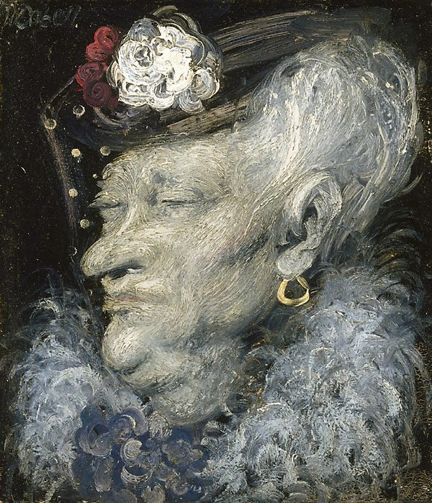

William Dobell, *Mrs South Kensington*, 1937, 3oil on wood panel, 8.2 x 33.2 cm. Art Gallery of New South Wales, Accession No. 7363. Copyright: Sir William Dobell Art Foundation.

An early example of this style can be seen in *Mrs South Kensington* (1937), which has been described as epitomizing ‘a bitter, desiccated and ageing upper class’, no doubt influenced by Dobell’s experience of the Depression and the social mores of London at the time.

During World War 11 Dobell served in the camouflage unit of the Royal Australian Air Force and the Civil Construction Corps. While at the R.A.A.F base at Rathmines NSW in 1943 he painted *The Billy Boy*, a portrait of a man named Joe Westcott, a Glasgow Irishman. Responsible for ‘boiling the billy’ (making the tea) he was reportedly more given to political debate than doing his job and clearly captured Dobell’s imagination. Appointed an Official War Artist during WWII, this period saw him produce some of his best-known images, among them *The Cypriot*, (1940, Queensland Art Gallery), a portrait of his friend Aegus Gabrielides, and *The Strapper*, (1941, Newcastle Art Gallery).

Dobell’s portrait of Joshua Smith, awarded the 1943 Archibald Prize, represented a major watershed in his life and career. Extremely popular, the work was seen by 154,000 visitors to the Art Gallery of NSW. However, accused of being a caricature by some unsuccessful Prize entrants, it was claimed that it didn’t meet the Archibald’s criteria. The case went to court and the claim was dismissed, though it left a bitter legacy for Dobell. He retreated to Wangi Wangi on the NSW central coast and painted landscapes (including of New Guinea) as well as continuing with numerous portrait commissions. In 1948 he won the Wynne Prize for Landscape with *Storm Approaching Wangi*, and the Archibald Prize again in 1957 for his portrait of fellow artist Margaret Olley. In 1964 he was knighted for his services to art. Dobell House at Wangi Wangi was established after his death in 1970.

**References and further reading:**

Adams, Brian, & Shirley, Cathy. (1981) *Yours Sincerely, Bill Dobell*, documentary film, Australian Broadcasting Commission and the William Dobell Art Foundation, 1981

Donaldson, Elizabeth. (2010) *William Dobell: An Artist’s Life*, Wollombi : Exisle Publishing.

Eagle, Mary. (1996) William Dobell, *Australian Dictionary of Biography*, Vol. 14, Melbourne University Press.

White, Judith. (April – June 2000) ‘William Dobell: Yours Sincerely’, *Australian Art Collector*, Issue 12,